Enterprise risk management (ERM)

Risk Management International Treasurer/January 31, 2000

Editor’s Note:
As more and more companies attempt to manage risk on an enterprise basis (see IT, 1/3/00), there’s a growing need for a new conceptual framework that would address organizational as well as theoretical issues.
This essay, contributed by Dr. Dick Hoppe of IntelliTrade, sketches a framework for organizing and evaluating enterprise-wide risk management. It does not prescribe the management organization itself, but rather provides a structure for looking at the tasks that must be performed. Using the framework, a company can take inventory of its own operations and determine whether its internal organization has covered the appropriate bases.

A Framework for
Managing Risk

By Dr. Richard B. Hoppe

A multidisciplinary approach to risk.

While risk-taking is essential if businesses are to prosper, uncontrolled and unmanaged risk is a prescription for organizational suicide. It follows then that the task of deliberately managing risk is a core organizational function, and not a mere “ad-hoc” activity relegated to treasury departments.
Nor is risk management a single-discipline function. Rather, it requires attending to a number of different tasks in a variety of disciplines. Ensuring that all the tasks are accomplished is critical to success and sometimes to the very survival of a firm.

Definitions of risk

To take risk is to expose oneself to the possibility of negative outcomes (see box on p.4). There are five sorts of potential negative outcomes that can result from taking risks; these are not sharp categories, but they warrant separation since they have different implications for estimation, control and management.
The types of negative outcomes are:

(1) Volatility. This is the sort of risk that is enshrined in Modern Portfolio Theory, the Capital Asset Pricing Model, and Value-at-Risk estimation (VaR). This sort defines risk as variability and almost universally uses the standard deviation as the measure of variability in order to employ orthodox stochastic statistics and the probability calculus in estimation and control.
(2) Catastrophic Failure. This is a single event or sudden concatenation of events that cripples or destroys an enterprise in a relatively short time. Recent
examples of catastrophic failure include Barings Bank and Long-Term Capital Management.
International Treasurer/January 31, 2000 2

(3) Erosive Loss. This is a pattern of gradual deterioration over time, ultimately leading to failure or, more recently, to being taken over or merged out of existence. While erosive loss might be thought of as catastrophic failure in slow motion, typically its causes, control and management are different from those appropriate to catastrophic loss. Most obviously, with erosive loss there is time to take measures to recover.
(4) Failure to meet goals or exceed benchmarks due to misallocation of resources. Among other things, this is a characteristic behavior of centrally planned economies, not only in sovereign nations but also in firms in which resource allocation decisions are made by people who are distant from the realities of the business.
(5) Failure to meet goals or exceed benchmarks due to underutilization of resources. In this case, a firm does not take enough risk and therefore displays mediocre performance due to excessive caution. This is a firm particularly vulnerable to takeover.

Sources of risk

Generating a “one-size-fits-all” list of sources of risk is impossible, since the sources will vary as a function of the business a firm is in. Each firm must identify the risk exposures of its operations given its particular constellation of activities. In addition to the three outlined in the box on p. 5, other candidates include: interest rate risk, volatility risk, operational risk, currency risk, sovereign risk, counter-party risk and model risk.
These are not risks as such; they are sources of both risk exposure and of opportunity. They are, therefore, the domains in which firms must take risks to succeed, the areas in which profitable enterprises are to be found, and they are the sources of danger.

Major functions

Regardless of risk source and negative outcomes, risk managers will have to perform three functions: estimate, control and manage.
Even though the three interact, they are often performed by different people in different disciplines and at different organizational levels. Because they are performed by people who have differing goals, time frames, knowledge, reward structures and responsibilities, managing the coordination of the functions is of critical importance. Cross-functional interfaces are prone to trouble in any organization.

• Estimate. There is now extensive literature on market risk estimation, using methods based in stochastic statistics. There is less consensus on how to model and estimate risk in many of the other exposures that might be in a company’s risk management framework.

International Treasurer/January 31, 2000 3

For example, estimating country risk is more art than science. Some months ago I attended a meeting of foreign credit managers of exporting firms at which a country risk expert, a PhD economist from a major US bank, spoke on his specialty. It turned out that informal exchanges among the managers about their recent experience with customers in various countries carried more useful information about country risk than did the expert’s political and macroeconomic remarks. Later he and I agreed that systematically gathering such experiences would be a valuable aid in his job.

• Control. Risk Control is concerned with identifying exposures, aggregating estimates, assessment and prioritizing risks, reporting, and contingency planning. This function uses the information produced by risk modeling and estimation. It is the bridge from data to action. The control function aggregates risk estimates across exposures, prioritizes them, and plans appropriate actions. It may also be responsible for executing contingency plans. This is the domain of a senior risk manager.
The reporting function is of particular interest. Sorting out who gets what information, in what form and when, is critical to the risk management enterprise.
Decision-makers need information that’s timely, comprehensible and that is presented in an actionable form. Often, a conceptual and informational chasm separates the quants from business managers; hence the way information is presented is key to its effectiveness.

In addition, decision-makers must know the basis for the estimates and their limitations.

Editor’s Note:
A common risk language is essential to effective risk management. “Risk means different things to different people, and ensuring that everyone is talking about the same thing is critical.”
—Dr. Dick Hoppe

• Manage. Risk management is concerned with setting policy and guidelines, managing the flow of information and making decisions about whether and when to invoke contingency, risk-mitigation plans. This is typically a senior manage-ment function and is heavily dependent on management’s understanding of the assumptions, limitations, and capabilities of both the estimation and control functions.
While risk estimation is often taken to be the central task of risk management, it is not. Quantifying risk is only the first step. Treasuries must approach risk on a multi-disciplinary level, if they are to make a value-added contribution to their enterprises.
International Treasurer/January 31, 2000 4

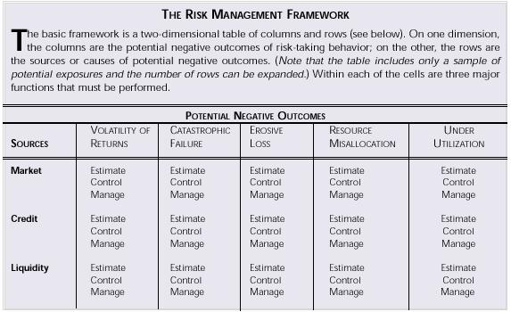

Dr. Richard Hoppe is a Principal at IntelliTrade, Inc., a market risk decision support firm. For more information, contact itrac@itrac.com.

